Project # 1

Analysis of Variance: ANOVA

ANOVA Programming Assignment

# The ANOVA Program

Use all the functions you developed for programming assignment: “FunctionsLists&CSV” and develop a function or functions that will perform the ANOVA calculations as specified below.

* Your program will read the input from the .csv file that has the measurements. The file will have at least 2 groups (columns) and at least 2 measurements per group (column).
* Your program will open the [FTable@5%.csv](mailto:FTable@5%25.csv) to read the F values for degrees of freedom 1 and 2: df1 and df2 as described in class when we created this file. If df1 and df2 are higher than what is in the table, your program should take the last value as described when we created the [FTAble@5%.csv](mailto:FTAble@5%25.csv) file.
* Your program will open an output file with a name to be selected by the user. The ANOVA results in the form of an ANOVA table will be printed to the output file and to the screen.
* Remember that each group of measurements (each column in the spreadsheet) can have a different number of data points ni shown in the equations below. Since you have different numbers of data points, you should store those in a list called nList like the average list and variance list. You can get this accomplished in the function that calculates the average list since you are counting the number of measurements.
* Review the presentation entitled “StatMethds&DataAnalysis ANOVA” and the equations presented there to arrive at the ANOVA Table:

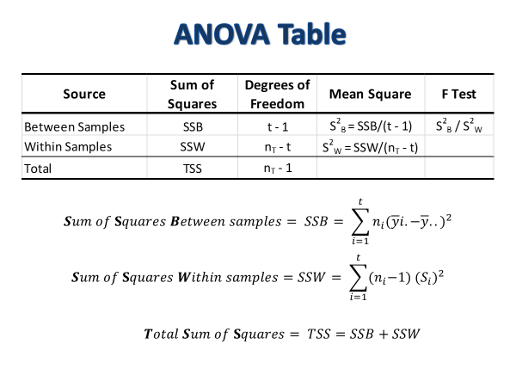

* A spreadsheet attached to this programming project should be consulted to determine how the equations work, use it. measurements from your input file should give the same results in the spreadsheet as your program.
* Your program output should be user friendly with information on the screen letting the user what to do, what to open, where the information will be read from, and where the results will be written to.

Take notes when I run my program. The output should follow the same format you see in the spreadsheet that does the same calculations you are performing in Python.